EXPT NO: 9 | TEXT CLASSIFICATION AND TEXT GENERATION USING TRANSFORMERS
DATE: 02.11.2026 | TEXT CLASSIFICATION AND TEXT GENERATION USING TRANSFORMERS

PRE-LAB QUESTIONS (PROVIDE BRIEF ANSWERS TO THE FOLLOWING QUESTIONS)

- What is a Transformer model in Natural Language Processing (NLP)?
A Transformer is a deep learning model architecture used in Natural Language Processing (NLP) to understand and process human language. It uses a mechanism called self-attention to identify relationships between different words in a sentence. Unlike traditional models such as RNNs, Transformers can process multiple words simultaneously, making training faster and more efficient. They are widely used in applications such as text classification, machine translation, question answering, text summarization, and text generation.

- What is BERT, and how is it used for text classification?
BERT stands for Bidirectional Encoder Representations from Transformers. It is a pretrained language model developed by Google that understands the context of words by analyzing both left and right sides of a sentence. BERT is widely used for text classification tasks such as sentiment analysis, spam detection, and topic identification. For classification, a pretrained BERT model is fine-tuned using labeled text data. It learns to assign appropriate categories to input sentences based on their meaning and context.

- What is fine-tuning in the context of pretrained language models?
Fine-tuning is the process of taking an already pretrained language model and training it further on a specific dataset to perform a particular task. A pretrained model such as BERT has already learned general language patterns, grammar, and word relationships from large amounts of text. During fine-tuning, the model adjusts its weights using task-specific labeled data. This improves its performance on tasks such as sentiment classification, question answering, and text recognition while requiring less training time than building a model from scratch.

- What is the difference between text classification and text generation?
Text classification and text generation are two important applications of Natural Language Processing. Text classification assigns predefined categories or labels to input text based on its meaning. For example, a movie review can be classified as positive or negative. Text generation, on the other hand, produces new text based on a given input or instruction. For example, a Transformer model can generate a summary of a paragraph or complete a sentence. Classification identifies the category of text, whereas generation creates new textual content.

- What is a sequence-to-sequence model, and how is it used in text generation?
A sequence-to-sequence model is a neural network architecture that converts an input sequence into an output sequence. It commonly consists of an encoder and a decoder. The encoder processes the input text and creates a representation containing its important information. The decoder uses this representation to generate the output text one token at a time. Sequence-to-sequence Transformer models such as T5 are widely used for text generation tasks, including summarization, translation, question answering, and sentence completion.

AIM
To implement text classification by fine-tuning a pretrained BERT model and develop a simple sequence-to-sequence text generation application using Transformer models.

SOFTWARE REQUIREMENTS
- Python
- Google Colab
- Hugging Face Transformers
- Hugging Face Datasets
- PyTorch
- NumPy
- Pandas
- Matplotlib

OBJECTIVES
Students will be able to:
- Understand the architecture and working of Transformer models in NLP.
- Understand the concepts of text classification and text generation.
- Load and preprocess text datasets for NLP applications.
- Fine-tune a pretrained BERT model for text classification.
- Evaluate the classification model using appropriate performance metrics.
- Implement a sequence-to-sequence application using a pretrained Transformer model.
- Generate text using the model's text generation capabilities.
- Analyze and compare the outputs produced by the Transformer models.

PROCEDURE
PART A: DATASET PREPARATION AND TEXT PREPROCESSING
Perform the following tasks:
- Load a text dataset such as the IMDb movie review dataset.
- Explore the dataset and examine sample text entries and their labels.
- Check the number of samples and the distribution of class labels.
- Separate the dataset into training and testing sets or use the predefined splits.
- Load a pretrained tokenizer corresponding to the BERT model.
- Tokenize the text using the tokenizer.
- Apply padding and truncation to maintain consistent input lengths.
- Convert the tokenized data into the required format for model training.
- Prepare the dataset for batch-wise processing.

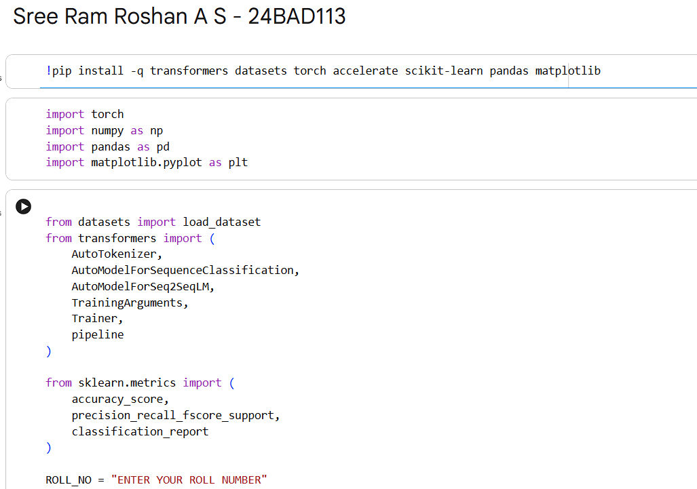
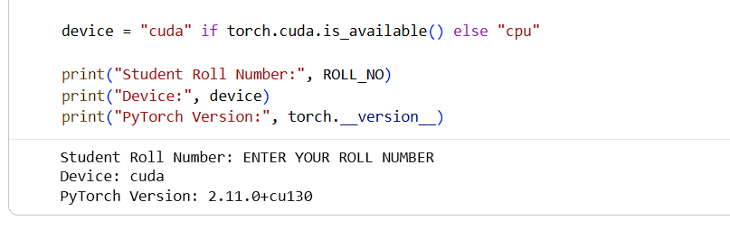
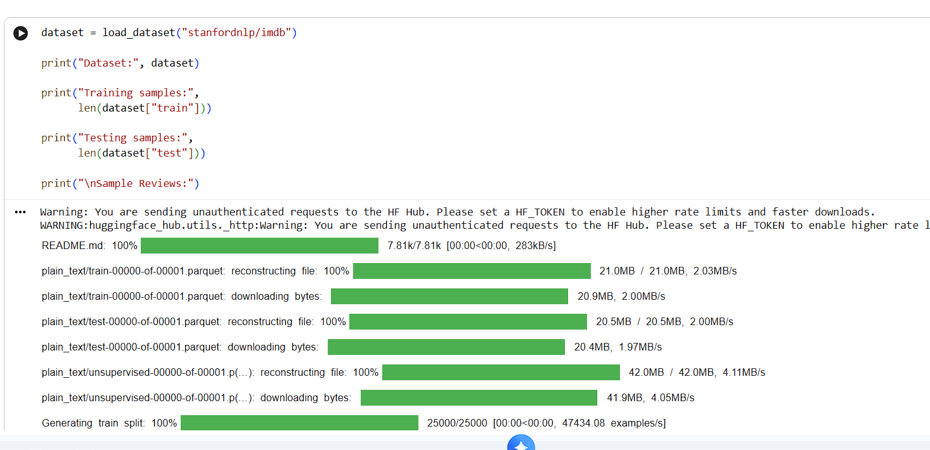
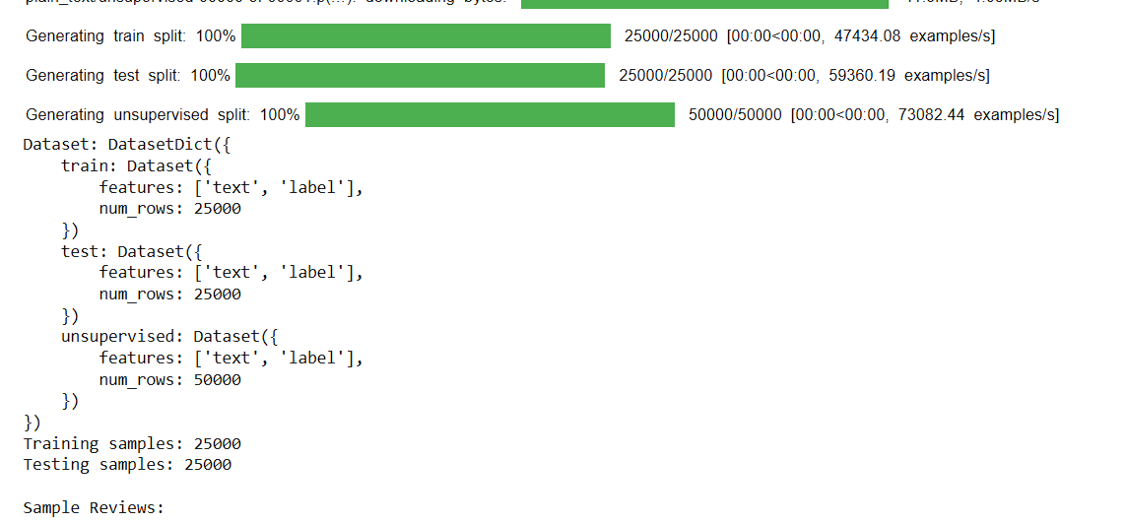
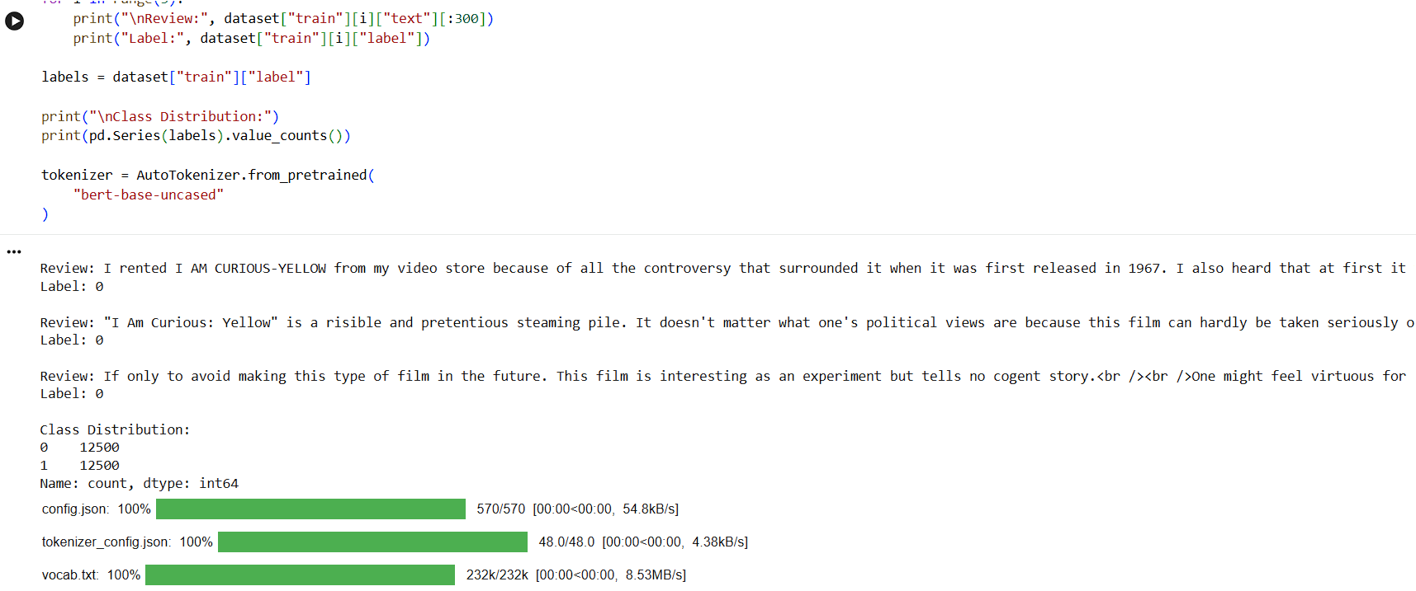
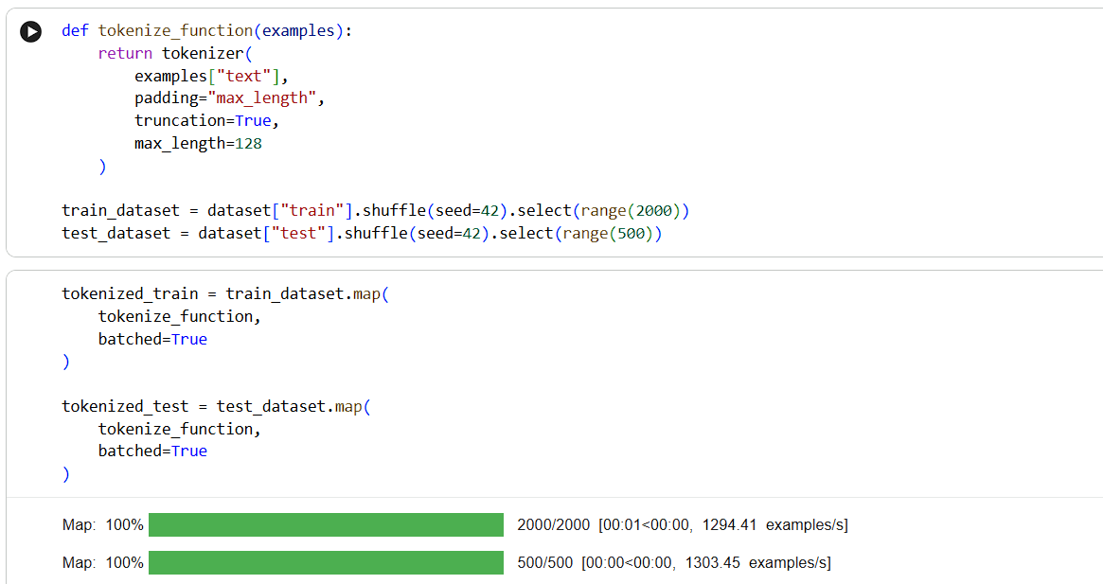
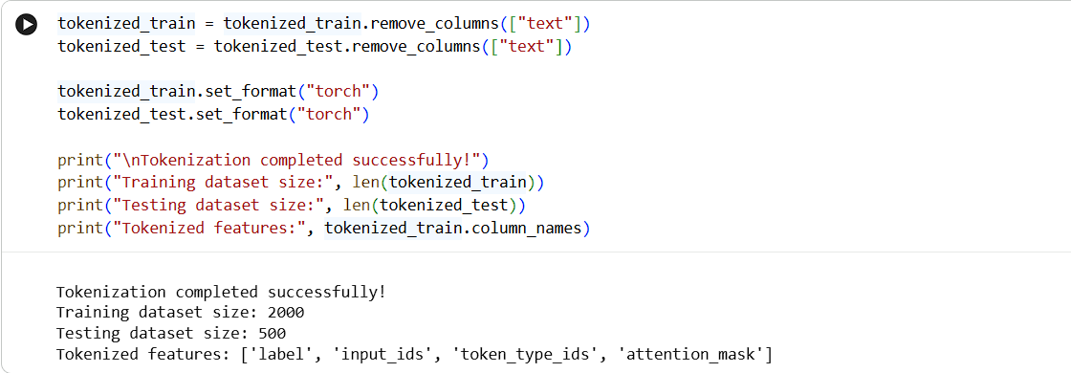

PART B: FINE-TUNING BERT FOR TEXT CLASSIFICATION
Perform the following tasks:
- Load a pretrained BERT model for sequence classification.
- Configure the model for the required number of classes.
- Prepare the tokenized training and testing datasets.
- Define the training parameters, including learning rate, batch size, and number of epochs.
- Fine-tune the BERT model using the training dataset.
- Evaluate the trained model using the testing dataset.
- Calculate appropriate performance metrics, such as accuracy, precision, recall, and F1-score.
- Test the model using new text inputs.
- Display the predicted class labels and corresponding evaluation results.
- Save the fine-tuned model and tokenizer.

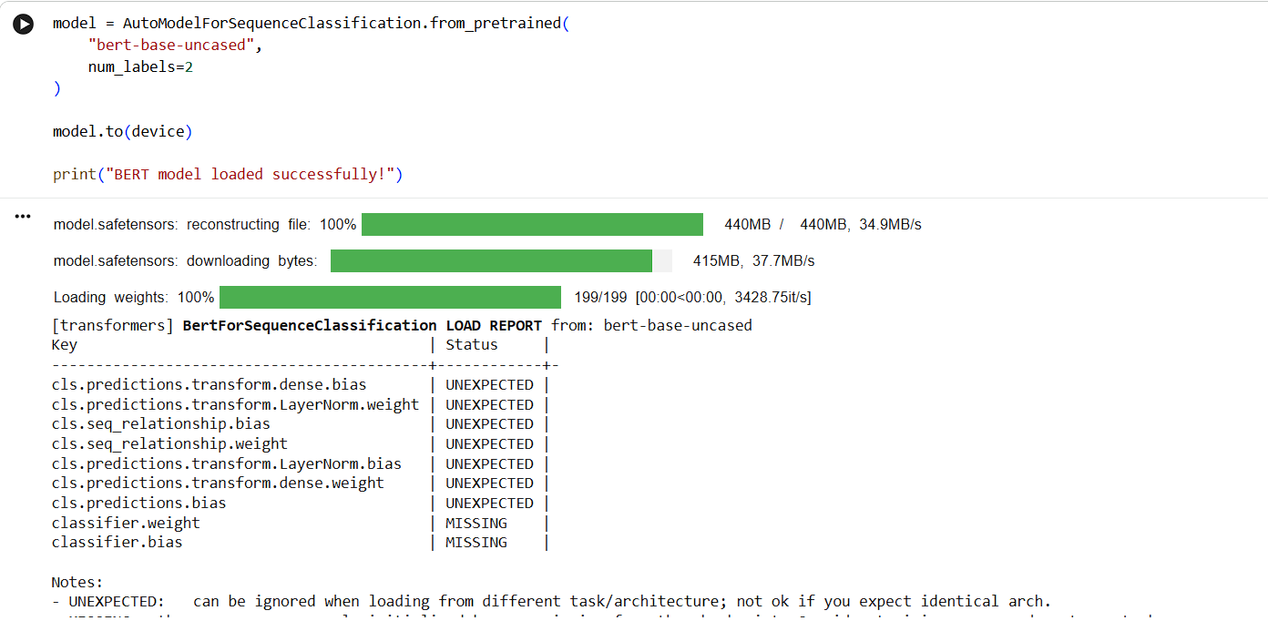
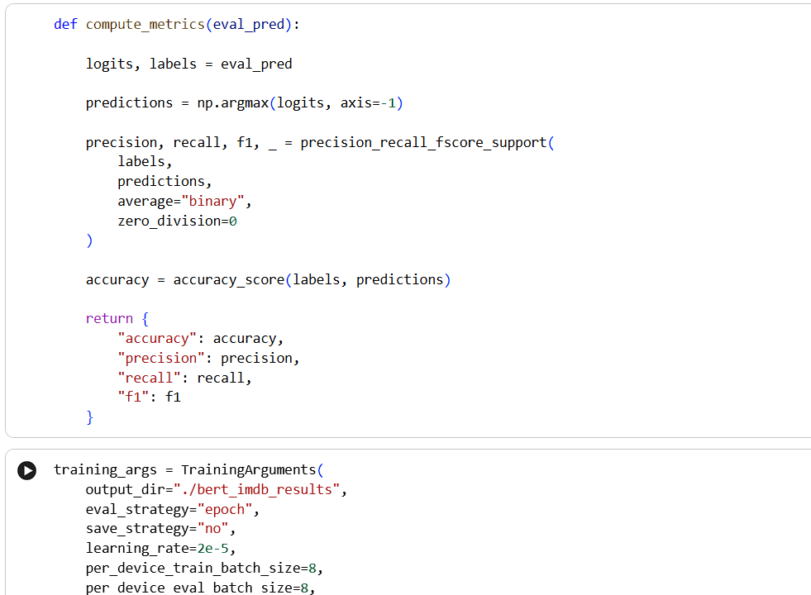
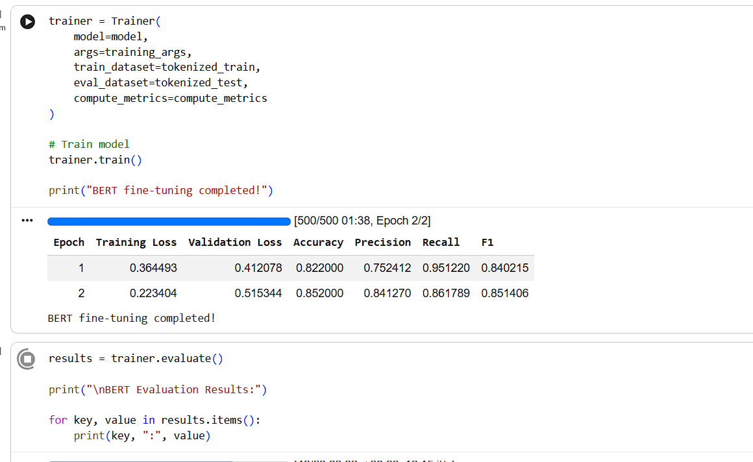
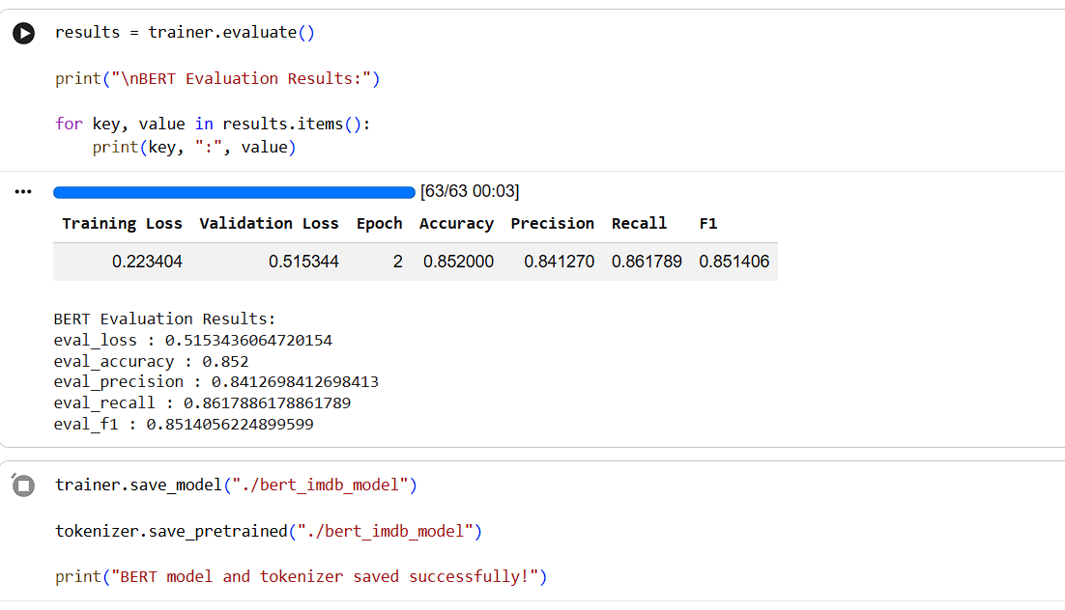

PART C: IMPLEMENTING A SEQUENCE-TO-SEQUENCE APPLICATION USING TRANSFORMERS
Perform the following tasks:
- Load a pretrained sequence-to-sequence Transformer model, such as T5-small.
- Load the corresponding tokenizer.
- Prepare a sample text input for the selected text generation task.
- Preprocess the input according to the model's requirements.
- Generate output text using the pretrained model.
- Apply appropriate generation parameters, such as maximum output length and beam search, where applicable.
- Display the input text and the generated output.
- Experiment with different input texts and generation settings.
- Observe how changes in the input and generation parameters affect the output.
- Save the generated outputs for further analysis.

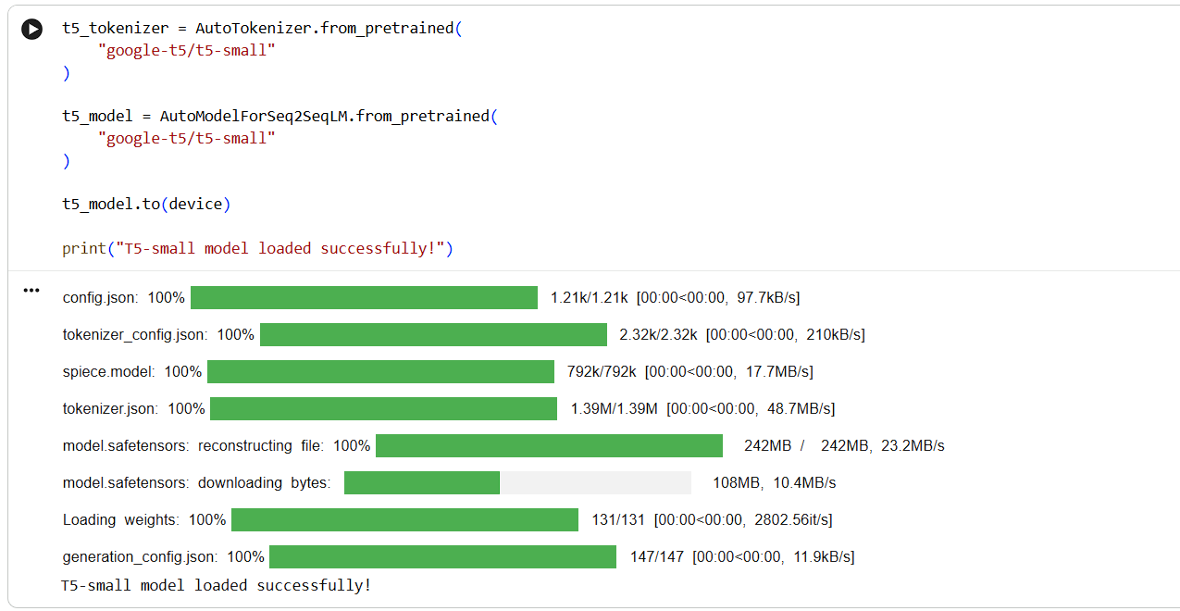
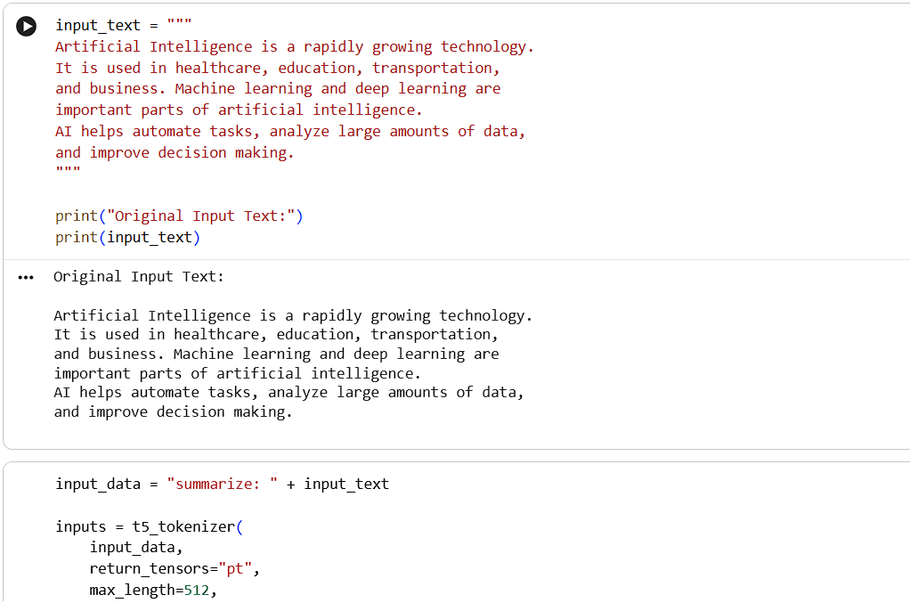
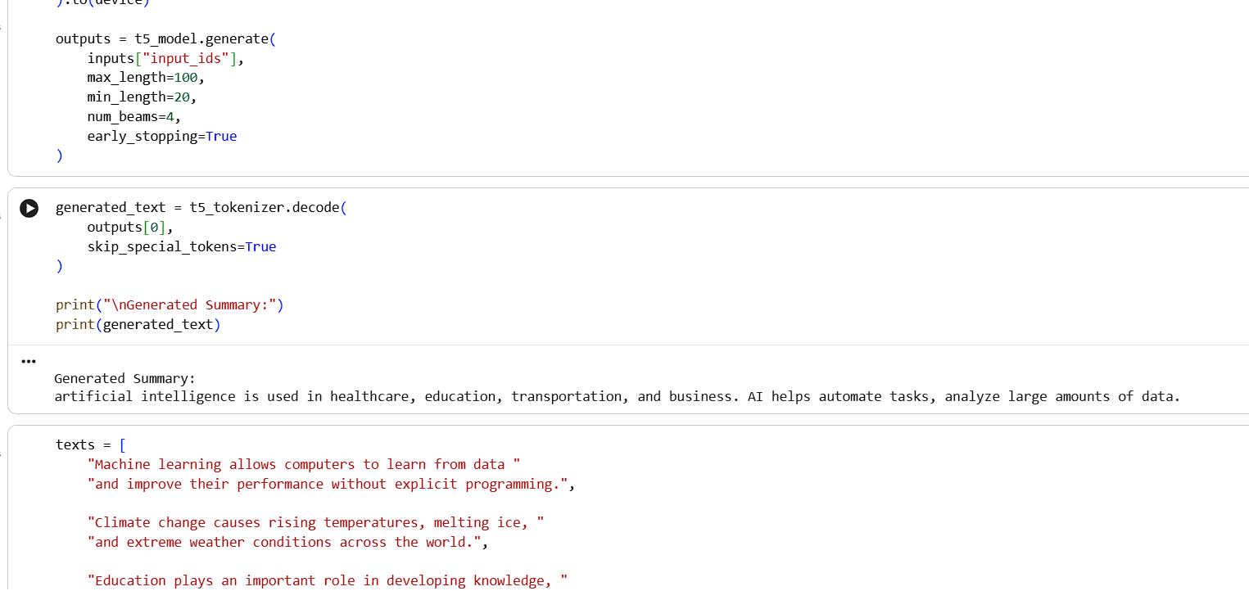
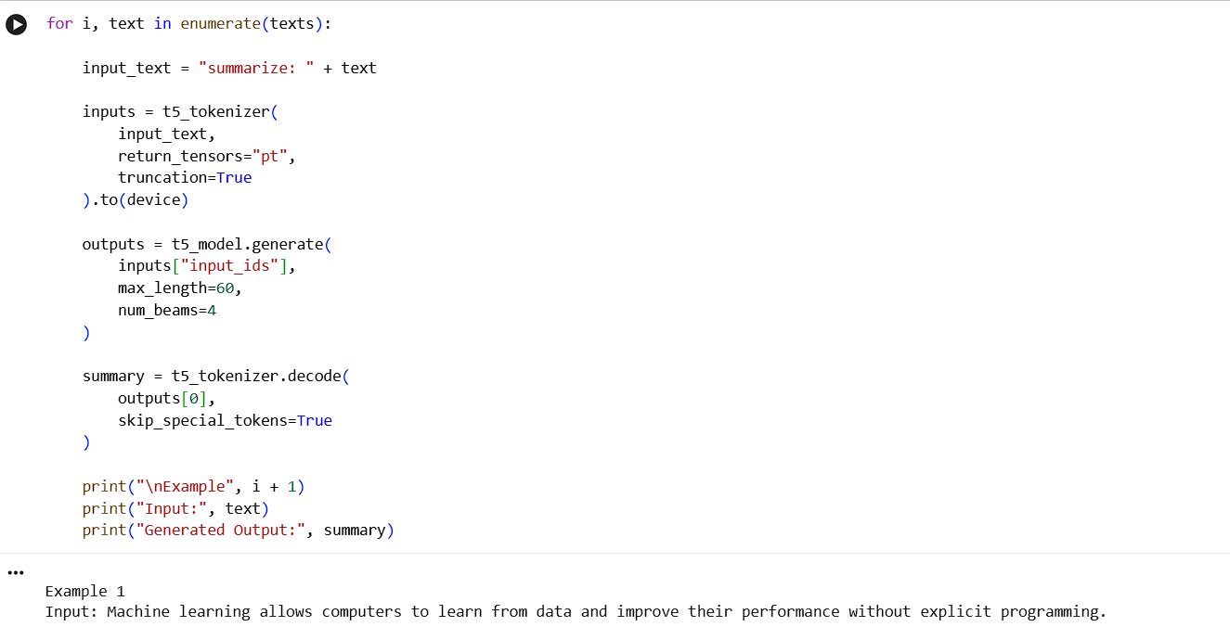
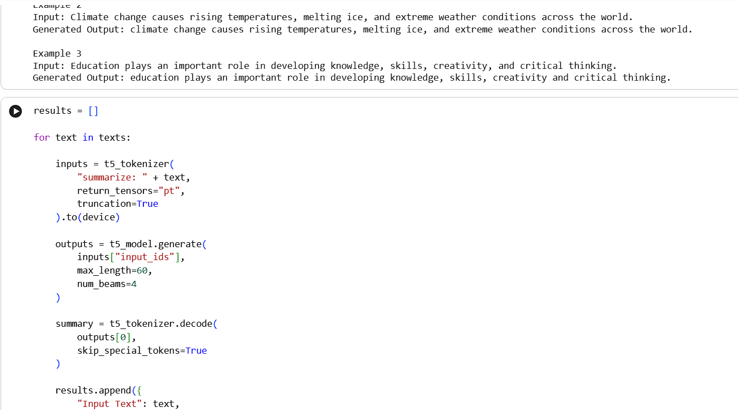
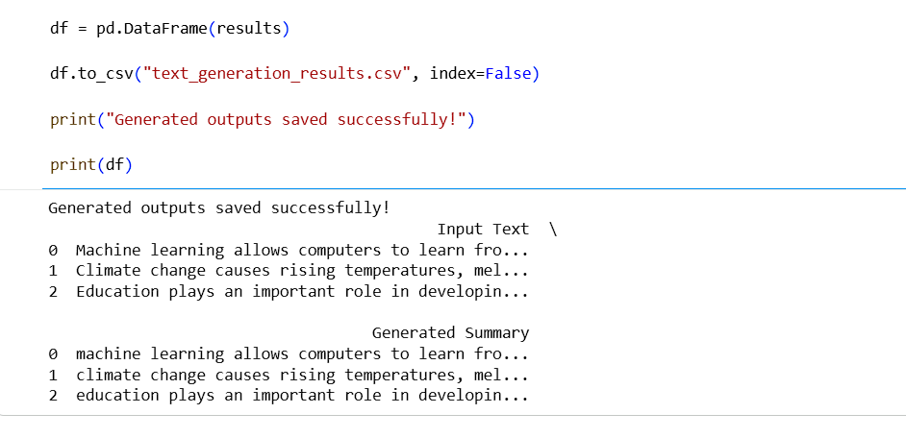

PART D: MODEL TESTING AND OUTPUT ANALYSIS
Perform the following tasks:
- Test the fine-tuned BERT model using sample positive and negative text inputs.
- Record the predicted class labels for the test inputs.
- Analyze the classification results using the selected evaluation metrics.
- Test the sequence-to-sequence model using different input texts.
- Compare the generated outputs for different inputs and generation settings.
- Examine the relevance, readability, and coherence of the generated text.
- Identify possible errors or limitations in the classification and generation outputs.
- Compare the applications of BERT-based classification and sequence-to-sequence text generation.
- Summarize the observations obtained from both models.

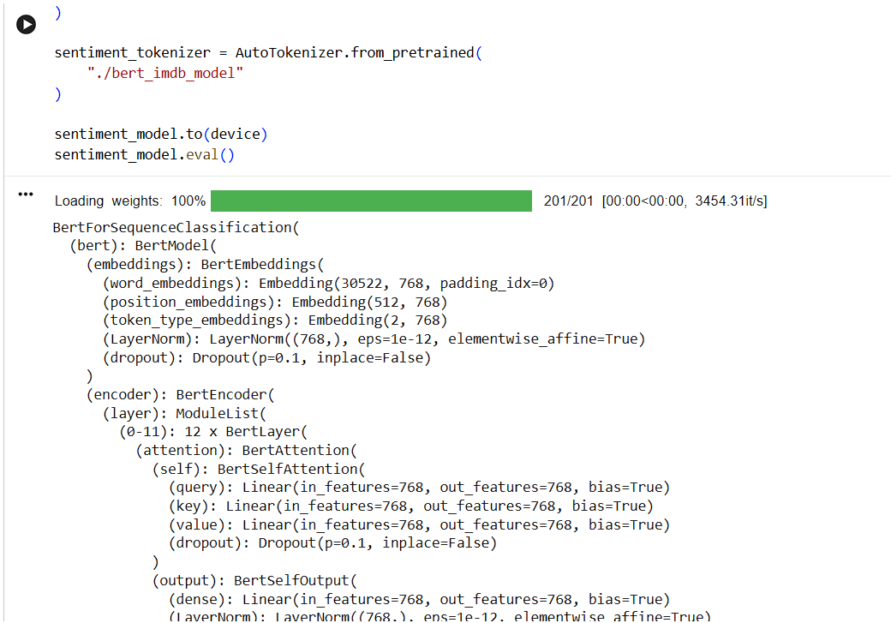
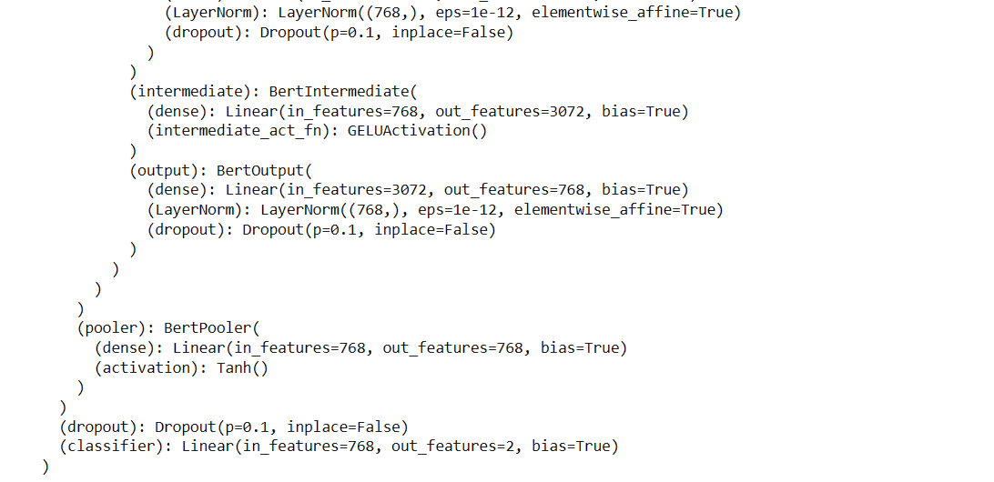
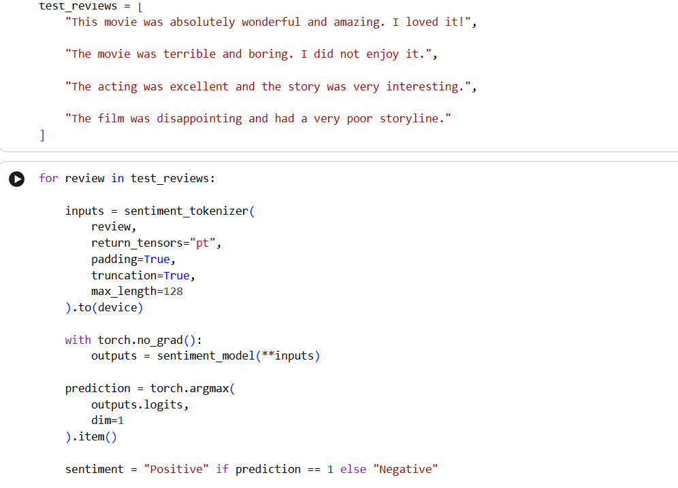
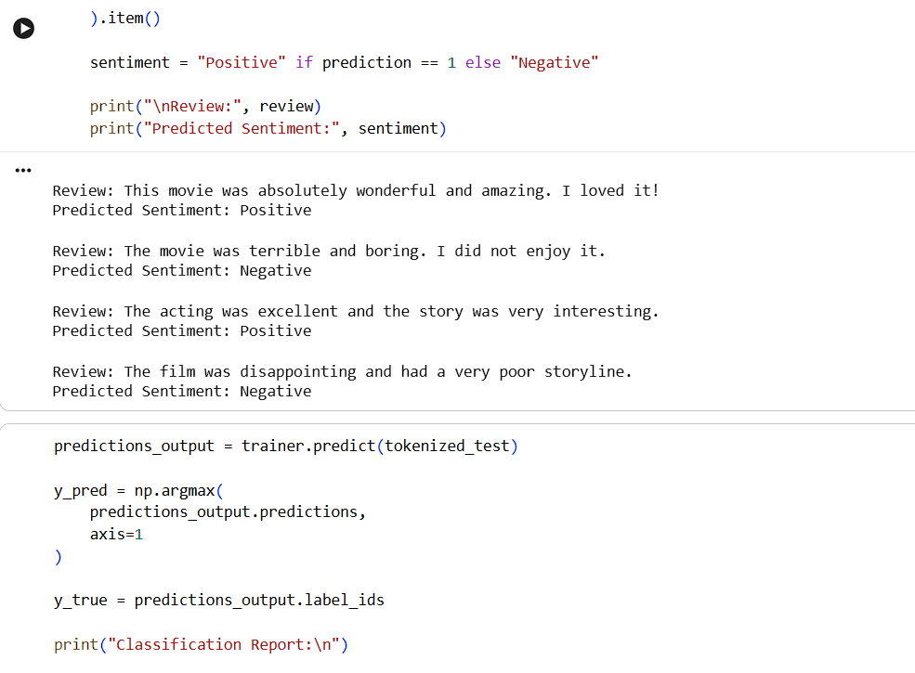
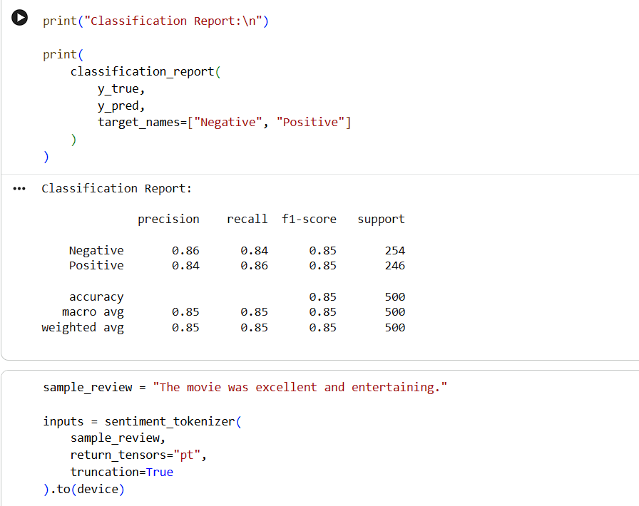
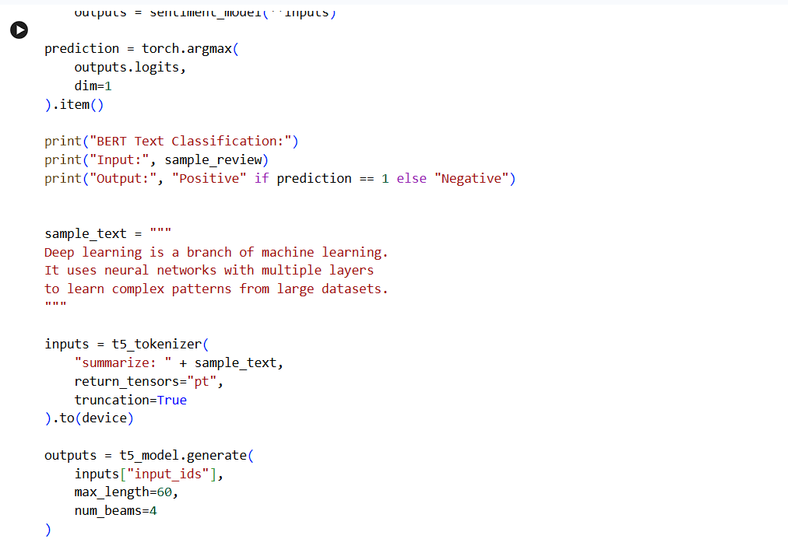
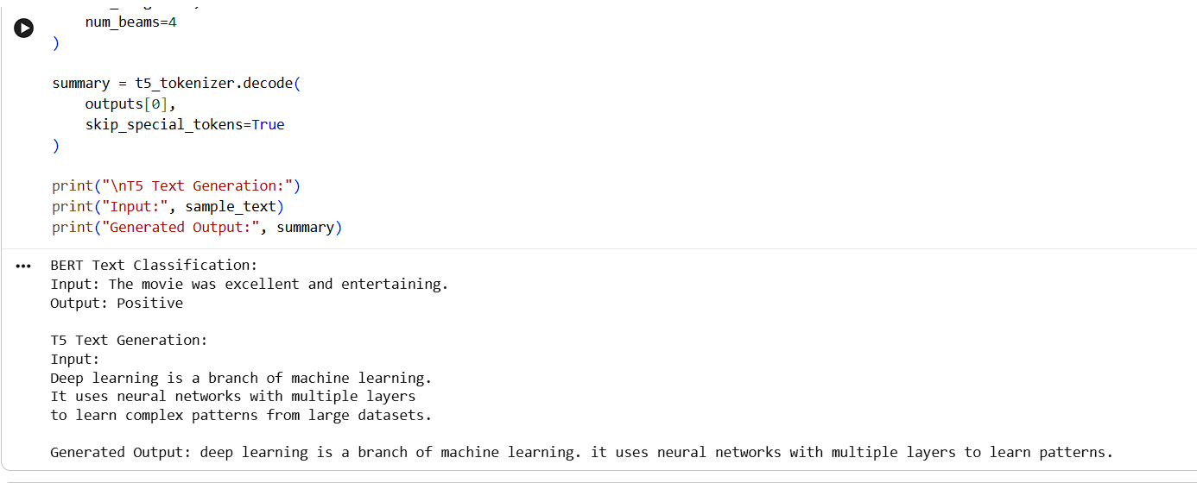
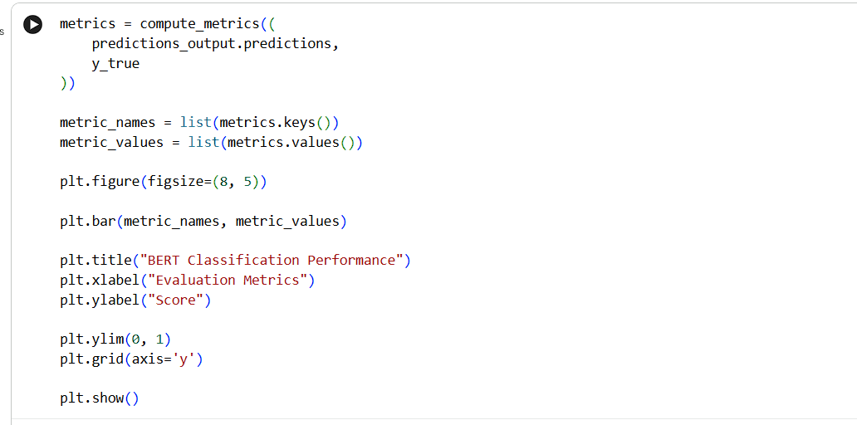
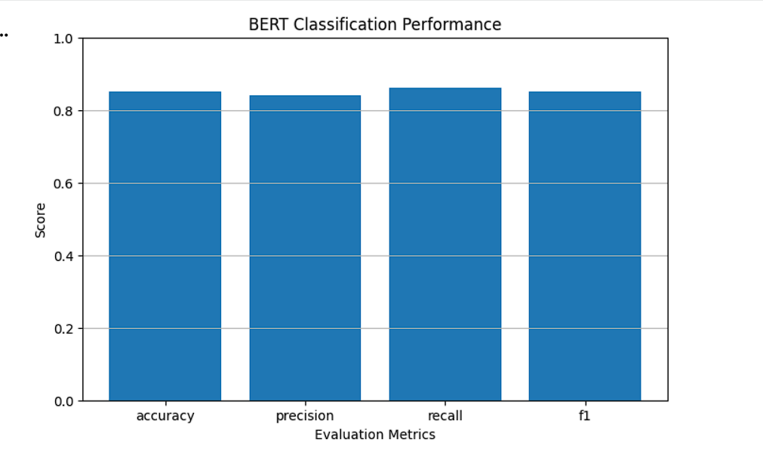
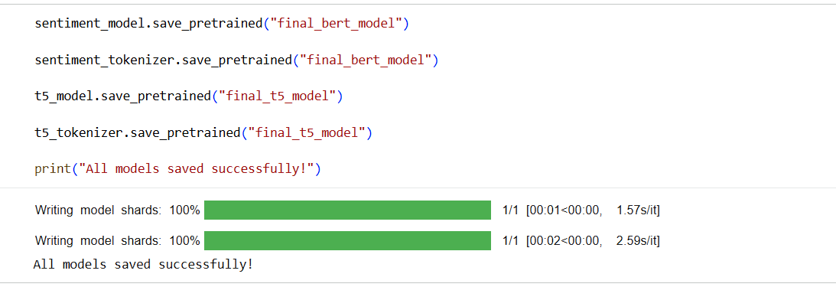

EXPECTED OUTCOME
Students will understand the architecture and applications of Transformer models in Natural Language Processing. They will learn to fine-tune a pretrained BERT model for text classification, preprocess textual data, and evaluate classification performance using appropriate metrics. Students will also develop a simple sequence-to-sequence text generation application using a pretrained Transformer model and analyze the quality and relevance of the generated outputs.

POST-LAB QUESTIONS (PROVIDE BRIEF ANSWERS TO THE FOLLOWING QUESTIONS)

- What is the role of BERT in text classification?
BERT plays an important role in text classification by understanding the contextual meaning of words and sentences. It uses bidirectional self-attention to analyze relationships between words from both directions. A pretrained BERT model can be fine-tuned using labeled datasets to classify text into different categories. For example, in sentiment analysis, BERT can identify whether a movie review expresses a positive or negative opinion. It improves classification performance by learning meaningful language representations and understanding the context of input sentences.

- Why is tokenization required before providing text to a Transformer model?
Tokenization is required because Transformer models cannot directly understand raw text. It converts sentences into smaller units called tokens, which may represent words, subwords, or special symbols. Each token is then converted into a numerical token ID that the model can process. Tokenization also helps handle unknown words, punctuation, and special tokens. For example, the BERT tokenizer converts a sentence into token IDs and applies padding and truncation to maintain consistent input lengths for efficient model training.

- What is the purpose of fine-tuning a pretrained BERT model?
The purpose of fine-tuning a pretrained BERT model is to adapt its existing language knowledge to a specific NLP task. BERT is initially trained on large text datasets to understand general language patterns and contextual relationships. Fine-tuning further trains the model using a smaller, task-specific labeled dataset. This allows it to perform tasks such as sentiment analysis, spam detection, and text classification more accurately. It also reduces the computational time and training effort compared with developing and training a completely new model.

- Mention any two-evaluation metrics used for text classification.
Two important evaluation metrics used for text classification are accuracy and precision. Accuracy measures the percentage of correctly classified predictions out of the total predictions made by the model. Precision measures how many of the samples predicted as positive are actually positive. These metrics help evaluate the performance and reliability of a classification model. Other commonly used metrics include recall and F1-score. Together, these evaluation measures provide a better understanding of how effectively a model classifies text into the correct categories.

- What is the role of the encoder and decoder in a sequence-to-sequence Transformer?
In a sequence-to-sequence Transformer, the encoder and decoder perform different but connected tasks. The encoder processes the input text and converts it into meaningful contextual representations using self-attention mechanisms. The decoder uses these representations to generate the output sequence step by step. It predicts the next token based on previously generated tokens and information from the encoder. For example, in text summarization, the encoder understands the original paragraph, while the decoder generates a shorter summary containing the important information.

- What is the difference between text classification and text generation?
Text classification involves assigning predefined labels or categories to given input text, whereas text generation involves creating new text based on an input or instruction. Classification models such as BERT can identify whether a movie review is positive or negative. Generation models such as T5 can produce summaries, translations, or other meaningful sentences. Classification produces a category or label as output, while generation produces a sequence of words or sentences. Both are important applications of Transformer-based Natural Language Processing systems.

- How does the maximum output length affect text generation?
Maximum output length determines the maximum number of tokens that a text generation model can produce for a given input. If the maximum length is too small, the generated output may be incomplete and important information may be missing. If it is too large, the model may generate unnecessary or lengthy content. Selecting an appropriate maximum output length helps maintain a balance between completeness and conciseness. It also affects generation time and computational requirements when using Transformer models such as T5.

- Mention one real-world application of Transformer-based text classification and one application of text generation.
One real-world application of Transformer-based text classification is sentiment analysis in customer reviews. Companies use models such as BERT to identify whether customer feedback is positive, negative, or neutral. This helps businesses understand customer opinions and improve their services. One application of text generation is automatic text summarization. Models such as T5 can convert lengthy documents or articles into shorter summaries containing the main points. These applications help automate language-related tasks and improve the efficiency of information processing.

SUGGESTIONS FOR DATASETS & MODELS
Datasets:
- IMDb Movie Reviews – https://huggingface.co/datasets/stanfordnlp/imdb
- GLUE Benchmark – https://huggingface.co/datasets/nyu-mll/glue
- SST-2 Sentiment Classification – https://huggingface.co/datasets/nyu-mll/glue

Pretrained Models:
- BERT Base Uncased – https://huggingface.co/google-bert/bert-base-uncased
- T5-small – https://huggingface.co/google-t5/t5-small

ASSESSMENT
Description | Max Marks | Marks Awarded
Pre Lab Exercise | 5
In Lab Exercise | 10
Post Lab Exercise | 5
Viva | 10
Total | 30
Faculty Signature

